

| **Title: Implement vector data styling and raster data styling in QGIS** |
| --- |

# Course Outcome:

# CO2 Apply the data analytics in the field of geospatial system

# Books/ Journals/ Websites referred:

# QGIS Installation Link: (Version 3.38.1)

# Resources used:

(Students should write)

______________________________________________________________________

# Algorithm: Vector data styling

# Open QGIS and Load Vector Data:

# Step 1: Start QGIS and load your vector data (e.g., shapefile, GeoJSON, etc.). Go to Layer-> Add Layer -> Add Vector Layer -> Upload the code file

# Step 2: Open the Layer Styling Panel

(Students should paste the screen shot)

# Step 3: Select your vector layer in the Layers panel.

(Students should paste the screen shot)

# Step 4: Right-click the layer and choose "Properties" or click on the "Layer Styling" panel on the right.

(Students should paste the screen shot)

# Step 5: Select a Symbology Type: In the Layer Properties window, go to the "Symbology" tab. Choose a symbology type (e.g., Single Symbol, Categorized, Graduated).

(Students should paste the screen shot)

# Step 6: Single Symbol Styling: For simple styling, choose "Single Symbol." Select the symbol and click on the symbol to open the Symbol Selector. Customize the symbol's color, outline, transparency, and other properties.

(Students should paste the screen shot)

# Step 6: Categorized Styling: Choose "Categorized" to style the layer based on a categorical attribute. Select the attribute column and click "Classify" to generate unique symbols for each category. Customize each category's symbol by clicking on the symbol next to each category.

(Students should paste the screen shot)

# Step 7: Graduated Styling: Choose "Graduated" to style the layer based on a numeric attribute. Select the attribute column and the classification mode (e.g., Equal Interval, Quantile). Click "Classify" to generate ranges and corresponding symbols. Customize each range's symbol by clicking on the symbol next to each range.

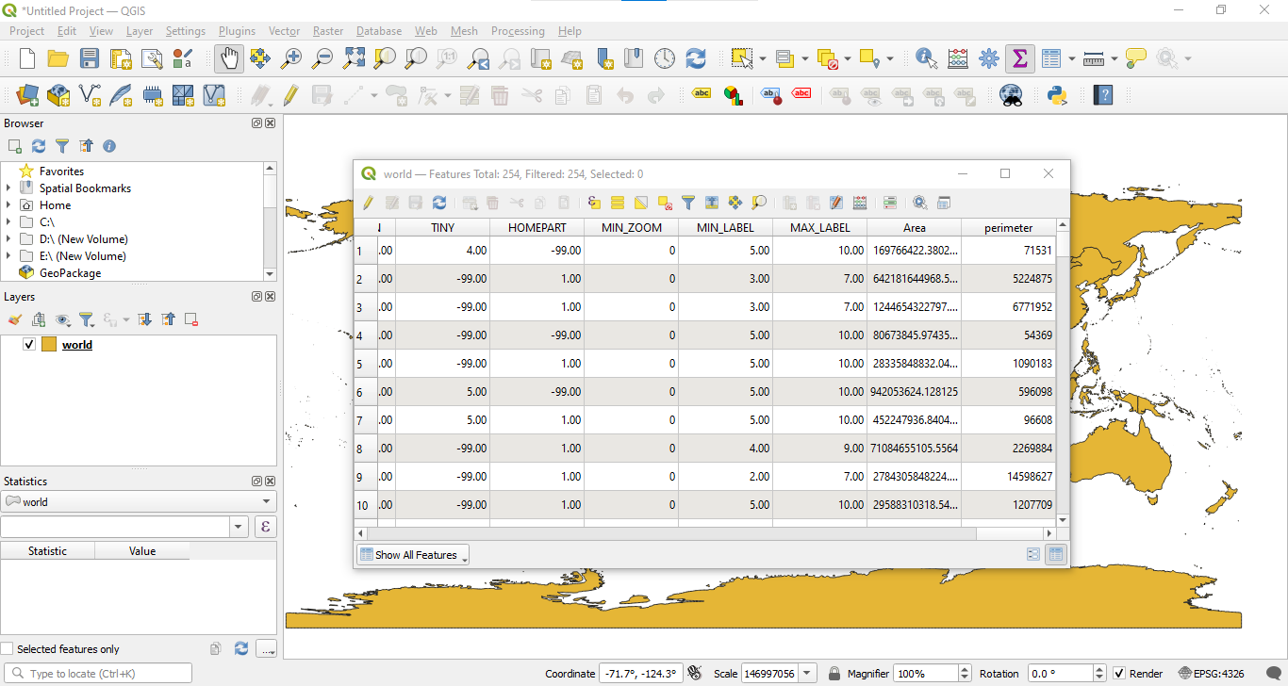

# Algorithm: Raster data styling

# Step 1 : Start QGIS and load your raster data (e.g., GeoTIFF, JPEG, etc.).

(Students should paste the screen shot)

# Step 2 : Open the Layer Styling Panel:

(Students should paste the screen shot)

# Step 3 : Select your raster layer in the Layers panel. Right-click the layer and choose "Properties" or click on the "Layer Styling" panel on the right.

(Students should paste the screen shot)

# Step 4 : Select a Render Type: In the Layer Properties window, go to the "Symbology" tab.

# Step 5: Choose a render type (e.g., Singleband gray, Singleband pseudocolor).

(Students should paste the screen shot)

# Step 6 : Singleband Gray: For grayscale images, choose "Singleband gray." Adjust the Min and Max values or use the "Load Min/Max Values" button. Choose a Contrast Enhancement mode (e.g., Stretch to MinMax, Stretch and Clip to MinMax).

(Students should paste the screen shot)

# Step 7 : Singleband Pseudocolor: For continuous data, choose "Singleband pseudocolor." Select a color ramp and adjust the Min and Max values. Click "Classify" to generate a color map based on the selected color ramp.

(Students should paste the screen shot)

**Task: Install QGIS Software version 3.38. Select different features and perform the vector data and raster data styling. Insert the output images for the respective task.**

# Platform used by the student:

# Following points should be written by students

# Different steps in Vector data styling and raster data styling

# Students need to write comments wherever needed

# Conclusion (Students should write in their own words):

Learnt about working with QGIS and implementing vector data styling and raster data styling in QGIS

**Post lab questions:**

**Q.1 How do different symbolization methods (e.g., simple symbols, graduated symbols, categorized symbols) impact the interpretation of vector data?**

**Q.2 How can attribute data be used to style vector layers effectively (e.g., using different colors for different categories or sizes based on numerical values)?**

**Q.3 Discuss in detail vector data styling and raster data styling.**